**Vasu remote build**

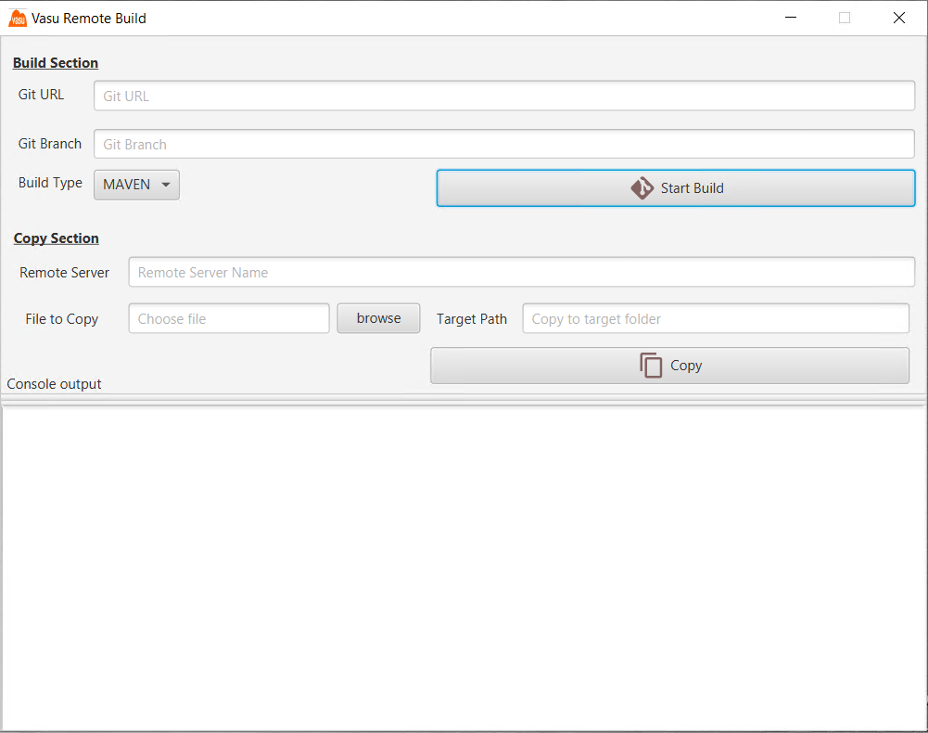

When you start tool for first time it will create many files and folders so please don’t delete any of the folder or file. This tool can selfheal if any of this files or folder get deleted so you don’t have to worry about recovering deleted tool files.

Files and folder get created under bin folder

Folder -> tmp, tmp/util

Files -> tmp/vasu_build_error_log, tmp/vasu_build_log, tmp/util/ tempbuild.ps1, tmp/util/temprun.ps1 , bin/vasurb.properties

**Note:** In bin/vasurb.properties you can provide the properties for all inputs except file_to_copy input.

This tool provide maven build for any repository which have maven as build tool. Also provides option to copy file from local to any remote servers.

This tool has three sections,

1. Build
2. Copy
3. Console output
4. **Build Section**

Build section contain two input git_url and git_branch, by default maven will be selected as build tool. Once you provide the input click on start_build button, It will first clone the repo in to <current_directory>/tmp folder. Once clone is start build and let user know the status by appending the console output.

**Prerequisite** : If global credentials are not set for git then you have to manually clone the branch in to <current_directory>/tmp directory. Once repo is cloned manually you can provide only branch name. When start_build is clicked again with different branch name it will checkout to given branch and start maven build.

If global credentials are set for git then tool will automatically clone and start build. All status will be updated into console output.

1. Copy Section

This section contain three input remote_server, file_to_copy and target_path. All three fields are mandatory fields. When user click on copy after providing needed input, it will copy the file from local machine to specified remote server folder.

There is a option to hardcode username and password for remote server login or you can choose to provide username and password by removing the hardcoded values.

1. Console Output

This section will get updated with operation output